Collateral Fragility:

The Stablecoin Footprint in Treasury Market

Introduction: The Shifting Sands of Safe Assets
U.S. Treasuries have long been the cornerstone of global finance—unrivaled as collateral, risk-free benchmarks, and safe havens. But cracks are forming. Foreign central banks are retreating, dealer balance sheets are stretched, and a new, volatile player has emerged: stablecoin issuers, now holding over $182 billion in T-bills. Unlike traditional buyers, stablecoins tie Treasury demand to the erratic crypto cycle, creating a fragile new dynamic. This analysis explores how this shift, combined with surging issuance and auction stress, signals a volatile future for the world’s “safest” asset.

1. A Fractured Buyer Base
The Treasury buyer landscape has transformed. Foreign central banks, once 33% of demand in 2020, now hold just 25%. Domestic banks (20% to 30%) and primary dealers (15% to 23%) have filled the gap, while stablecoins have surged to ~6% of Treasury holdings, concentrated in T-bills. This reliance on intermediaries and crypto-backed buyers introduces systemic risks tied to balance sheet constraints and digital asset flows.
- Chart 1: Treasury Demand Composition (Foreign CBs, Banks, Dealers, Stablecoin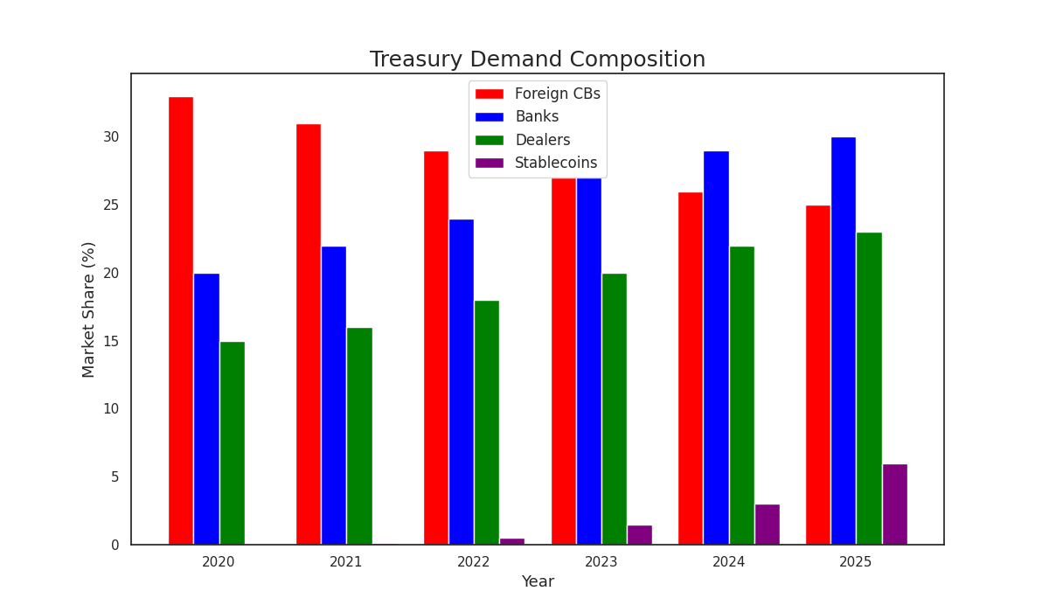This bar chart shows the declining market share of foreign central banks (red) and the rising share of domestic banks (blue), dealers (green), and stablecoins (purple), highlighting a less stable, more fragmented demand base.

2. Dealers Under Pressure
Primary dealers, the market’s shock absorbers, are nearing their limits. Net Treasury inventories have climbed, pushing Supplementary Leverage Ratio (SLR) utilization to approximately 95%, according to NY Fed data. When dealers hit their capacity ceiling, their ability to absorb new issuance is diminished, which can lead to weaker auctions and reduced market liquidity—a dynamic that has become more visible in recent data.
- Chart 2: Dealer Balance Sheet Utilization (% of SLR Capacity
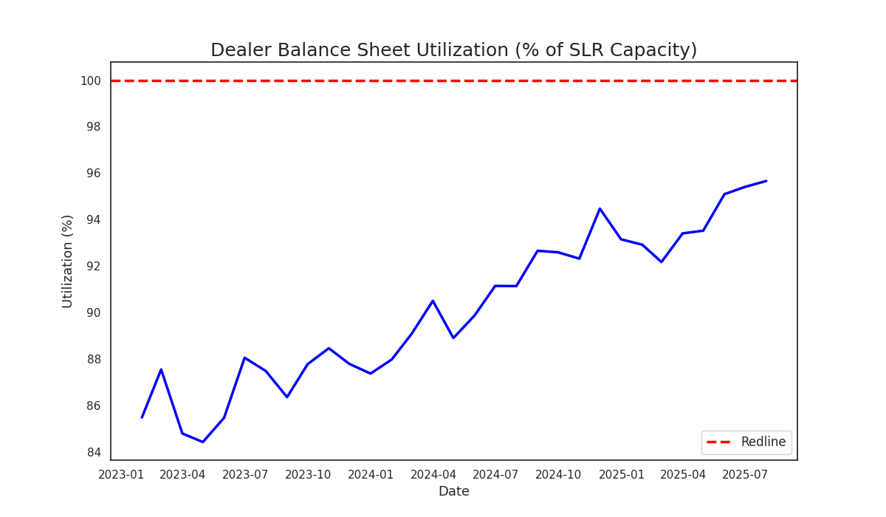This line chart tracks utilization rising from 85% in 2023 toward 95%, approaching the 100% regulatory redline.

3. Auction Stress Signals Fragility
Treasury auctions are showing clear signs of stress. For example, a recent 10-year note auction tailed, with its high yield settling above the when-issued yield, indicating weaker-than-expected demand. Data from Treasury reports shows that over 30% of auctions in the 2024-25 period have tailed. These are not isolated incidents but rather may be an indication of a structural weakening in demand from natural buyers.
Chart 3: Share of Treasury Auctions Tailing (Rolling 12M %) 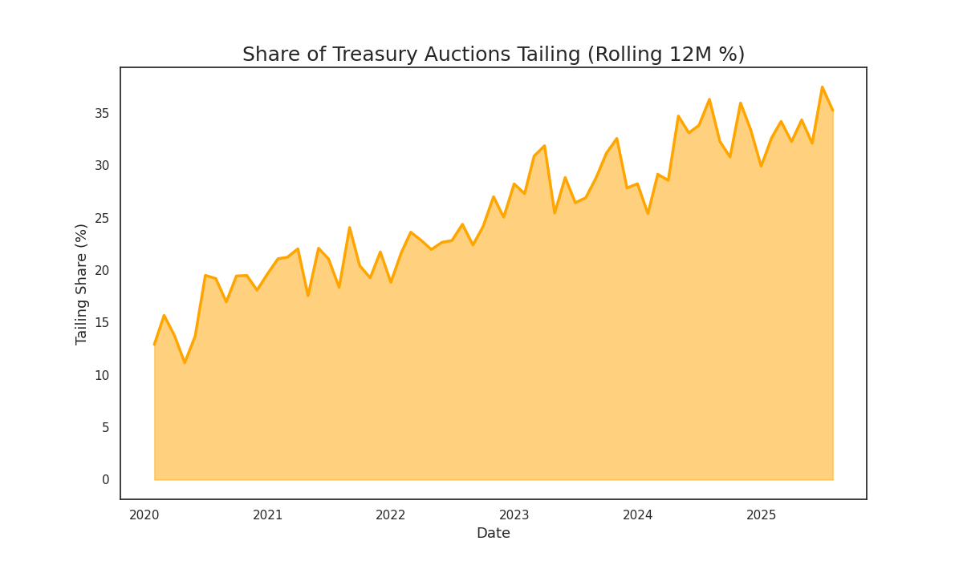This area chart shows the share of auctions tailing has risen from ~15% in 2020 to ~35% in 2025, reflecting persistent demand weakness, particularly at the long end of the curve.

4. Stablecoins: A Volatile Anchor
Stablecoins, holding a significant portion of their reserves in T-bills, help anchor demand at the front end of the curve. However, this demand is driven by crypto market flows rather than traditional economic fundamentals. This dynamic could be contributing to a widening of the 10-year term premium, as strong, crypto-linked demand for bills coexists with weaker fundamental demand for longer-duration bonds.
- Chart 4: 10Y Term Premium vs. Stablecoin Treasury Holding
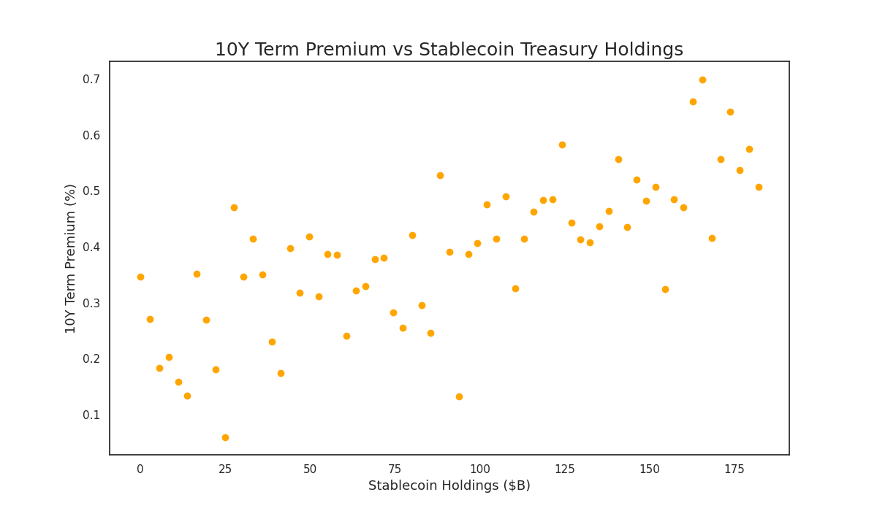
- This scatter plot shows a positive correlation between the growth in stablecoin holdings ($0 to $182B) and the 10Y term premium, suggesting a tangible link between crypto-driven demand and long-end Treasury pricing.

5. A Divided Curve
The Treasury market appears to be bifurcating. T-bill auctions continue to see robust bid-to-cover ratios, often around 3.2x, supported by strong demand for high-quality collateral and buying from stablecoin issuers. In contrast, longer-dated bond auctions have seen coverage ratios decline, now averaging closer to 2.4x. This split underscores a market where technical demand factors at the short end may be masking deeper vulnerabilities elsewhere.
Chart 5: Bills vs. Bonds Coverage Divergence
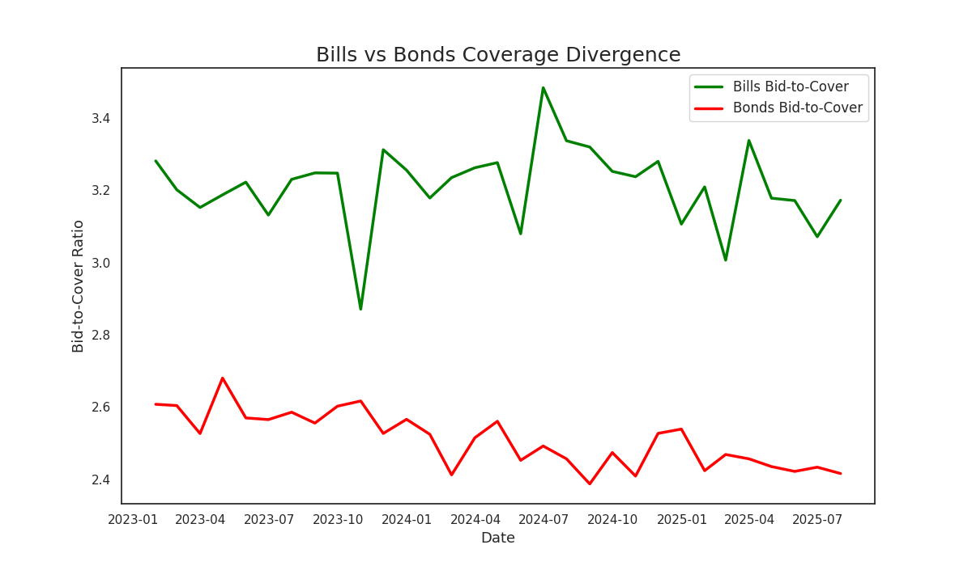This line chart contrasts the steady bid-to-cover ratio for bills (green, ~3.2x) with the declining ratio for bonds (red, ~2.4x), highlighting the growing divergence.

6. Stablecoins’ Growing Footprint
Stablecoins now account for an estimated 3% of the ~$6 trillion T-bill market. This represents a substantial footprint for an asset class that was a negligible holder of Treasuries just a few years ago. This demand is procyclical, meaning it is tied to the volatile cycles of the broader crypto market, and could risk rapid reversals in the event of large-scale redemptions.
Chart 6: Stablecoin Share of Global T-Bill Demand (%)

  - This chart tracks the rise of stablecoins to a 3% share of the T-bill market by 2025, illustrating their rapid emergence as a significant new buyer.

7. Collateral Stress on the Rise
Our proprietary collateral shortage index, which blends repo fails statistics and dealer stress proxies, has been trending higher. The pattern is reminiscent of periods preceding funding market stress, such as the 2019 repo crisis. This suggests that as dealer balance sheets fill up with Treasury inventory, mechanical funding constraints, rather than credit risks, are becoming a key threat to market stability.
Chart 7: Collateral Shortage Index (Repo Fails + Dealer Stress Proxy
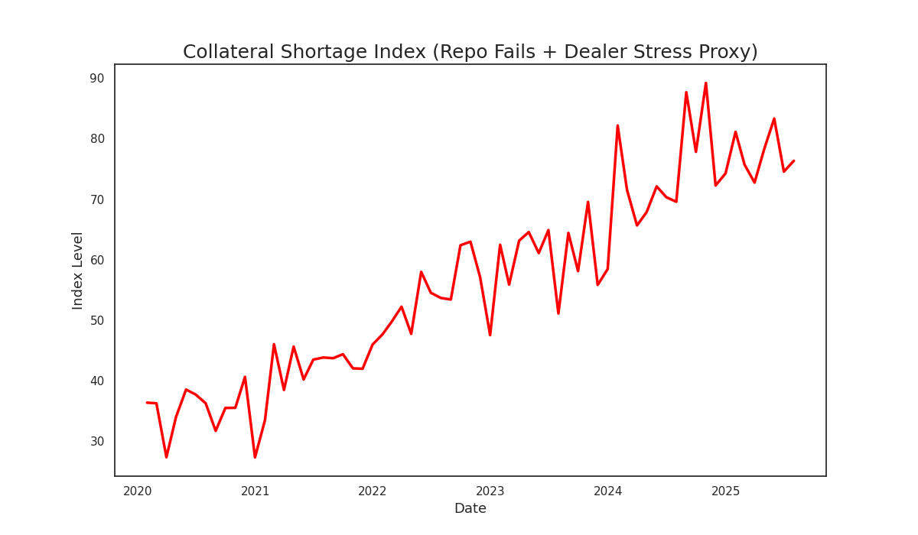
This line chart shows the index rising from a level of 30 to 80 since 2020, signaling growing funding market risks.

8. Crypto’s Funding Market Influence
The repo market, crucial for funding and liquidity, is showing increasing correlation with crypto market flows. Spikes in stablecoin issuance can increase demand for T-bills, but large outflows or redemptions could have the opposite effect, potentially tightening funding conditions. The result is that Treasury market liquidity is becoming increasingly tethered to the sentiment and volatility of digital assets.
Chart 8: Repo Stress vs. Bitcoin/Stablecoin Flows
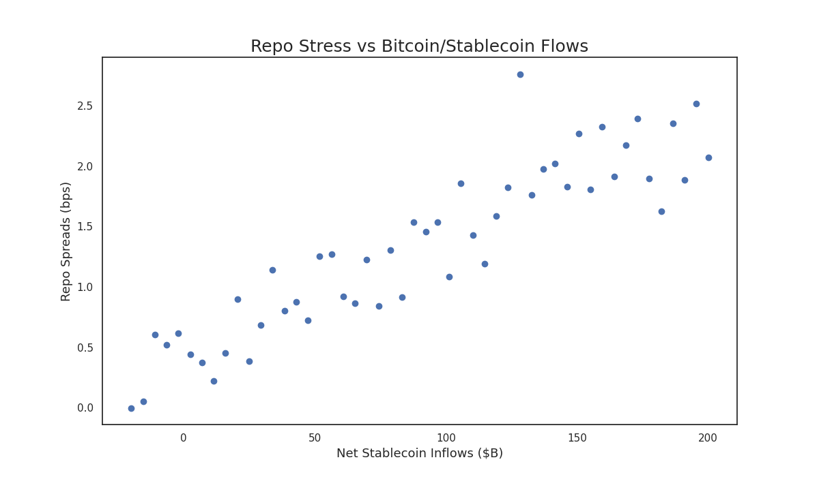
This scatter plot correlates repo spreads (bps) with net stablecoin inflows ($B), showing a positive linkage that appears to be amplified during periods of high crypto market activity.

9. Volatility Spillovers
The contrast in volatility between U.S. Treasuries (annualized vol of ~6%) and Bitcoin (annualized vol of ~70-90%) is stark. Historically, these markets operated in separate universes. However, the linkage created by stablecoin reserves means that shocks in the crypto market now have a potential transmission channel into the market for U.S. government debt, a novel risk for a sovereign bond market.
Chart 9: Cross-Asset Volatility (10Y Treasuries vs. Bitcoin)
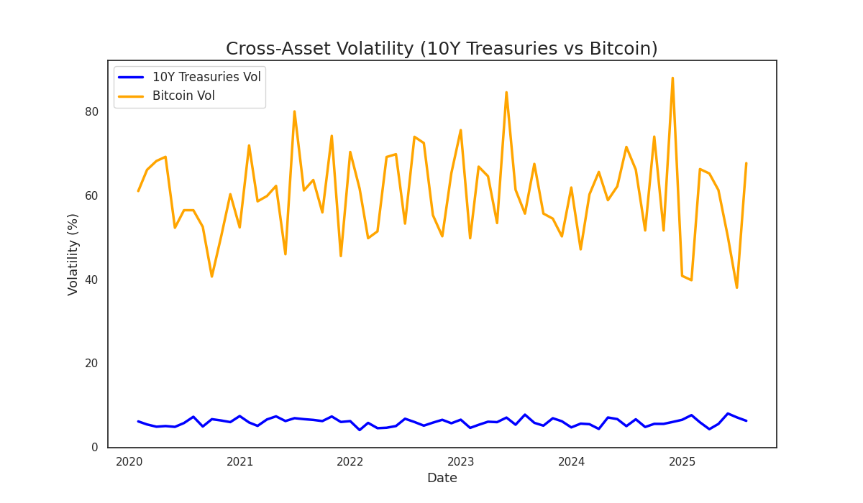
This line chart displays the historically low and stable volatility of 10Y Treasuries (blue) against the high and erratic volatility of Bitcoin (orange).

10. The Supply-Demand Imbalance
Looking ahead, the supply and demand picture for Treasuries presents a challenge. Net Treasury issuance is projected to be substantial, while the pool of natural, price-insensitive buyers like foreign central banks is smaller than it once was. This suggests that marginal demand will have to come from more price-sensitive buyers.
Chart 10: Projected Treasury Issuance vs. Projected Natural Demand
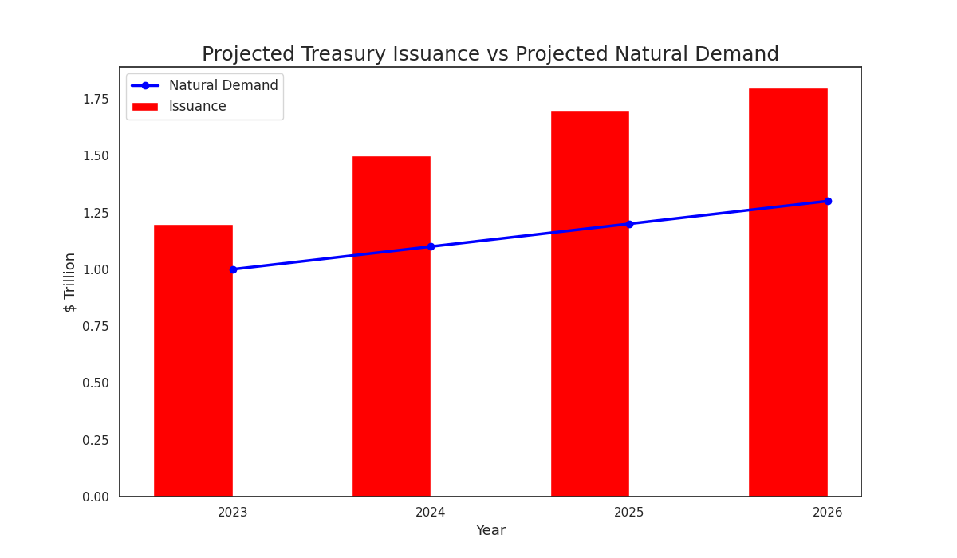
This bar-line chart shows projected issuance (red bars) consistently outpacing projected natural demand (blue line) through 2026, signaling a growing supply-demand gap.

Conclusion: A New Collateral Regime
The Treasury market is operating under a new set of rules. The monolithic safety of the past is being challenged by a more complex reality of constrained dealers, surging issuance, and the emergence of stablecoins as a significant, yet volatile, new source of demand. For investors, this environment may require monitoring crypto flows as a new leading indicator for funding markets and preparing for a higher baseline of volatility. The stablecoin presence is now a structural feature of the Treasury market—and collateral fragility is the result.

